|  |  |  |
| --- | --- | --- |
| **LAB101Assignment** | **Type:** | **LongAssignment** |
| **Code:** |  |
| **LOC:** | **150** |
| **Slot(s):** | **3** |

**Title**

Memcached.

**Background Context**

Memcached is a high-performance, distributed memory object caching system, generic in nature, but originally intended for use in speeding up dynamic web applications by alleviating database load.

Read more at <http://memcached.org/>

**Program Specifications**

There are some main functions that we use with Memcache and they are as follows:

1. Store data: sets a given key with a given value
2. Retrieve item: gets the value for a specified key
3. Delete item: remove a key and cache data
4. Flush all existing items: removes all keys and cached data
5. Exit the program.

***Function details:***

1. Function 1: When we store data using Memcache there are 3 parts to storing the data, those three parts are the key, the value, and the expiry time of the cached item. The key is used to reference the stored data.
   * The key that will be associated with the item.
   * The variable to store. Strings and integers are stored as is, other types are stored serialized.
   * Expiration time of the item. If it's equal to zero, the item will never expire. You can also use Unix timestamp or a number of seconds starting from current time, but in the latter case the number of seconds may not exceed 2592000 (30 days).
2. Function 2: Retrieve item, returns previously stored data if an item with such key exists.
3. Function 3: Deletes an item with the key.
4. Flush all existing items: The flush will expire all items up to the ones set within the same second.

***Expectation of User interface:***

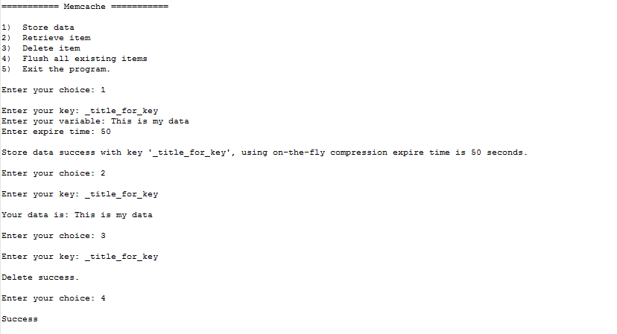

**Guidelines**